# Lesson 78 单词讲解

1. calm v. 使镇定，镇静

calm my nerves

calm down

adj. 镇定的

keep / stay calm

be calm

1. concentration n. 集中，专心；浓缩

concentrate v. 集中，专心；浓缩

1. suffer v. 受苦，受害；忍受，经历

suffer from the illness suffer pain

1. temper n. 脾气

a bad temper

lose one’s temper

entitle [in'taitl] v.以…为名

calm [kɑ:m] v.使镇定

nerve [nə:v] n.神经

concentration[ˌkɔnsən'treiʃən] n.集中，专心

suffer ['sʌfə] v.受苦，受害

symptom ['simptəm] n.症状

temper ['tempə] n.脾气

appetite ['æpitait] n.胃口，食欲

produce [prə'dju:s, 'prɔdju:s] v.拿出

urge [ə:dʒ] v.力劝，怂恿

satisfaction [ˌsætis'fækʃən] n.满意，满足

delighted [di'laitid] a.欣喜的

# Lesson 78 课文&语法讲解

1. After reading an article entitled 'Cigarette Smoking and Your Health' I lit a cigarette to calm my nerves.

蓝色部分都是非谓语动词

light v. 照亮，点着

light lit lit

1. I had all the usual symptoms of someone giving up smoking: a bad temper and an enormous appetite.

big large huge vast great giant

immense fantastic titanic gigantic

My friends kept on offering me cigarettes

1. They made no effort to hide their amusement whenever I produced a packet of sweets from my pocket.
2. When my old friend Brian urged me to accept a cigarette, it was more than I could bear.
3. I took one guiltily, lit it and smoked with satisfaction.
4. My wife was delighted that things had returned to normal once more.
5. Anyway, as Brian pointed out, it is the easiest thing in the world to give up smoking.L17 L37 形式主语 as是特殊非限定性的定语从句

But as they soon discovered, disguises can sometimes be too perfect.

# Lesson 78 知识拓展

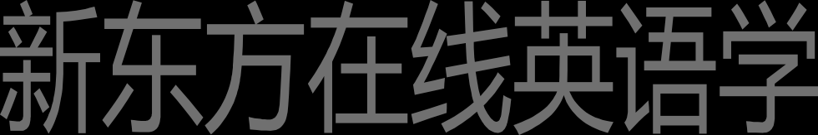补充内容: keep 词组

keep 词组

My friends kept on offering me cigarettes. Please keep off the grass.

He kept away from the party.

keep 词组

Under my essay, the teacher wrote, “Good work! Keep it up !” He ran so fast, I could not keep up with him.

keep 词组

A big notice on the door said, “Keep out!” The cat was kept in during the fireworks.

keep 词组

I think he kept the meeting on purpose.

away from Keep the floor. I have just cleaned it.

Off

keep 词组

He kept making the same mistake. on

She has just begun a diary. I wonder how long she will keep it .

up

